ASSIGNMENT 2

CSA0272 C PROGRAMMING

S.K. LOHIT DEVESHWAR

192211054

CSE DEPARTMENT

1ST QUESTION

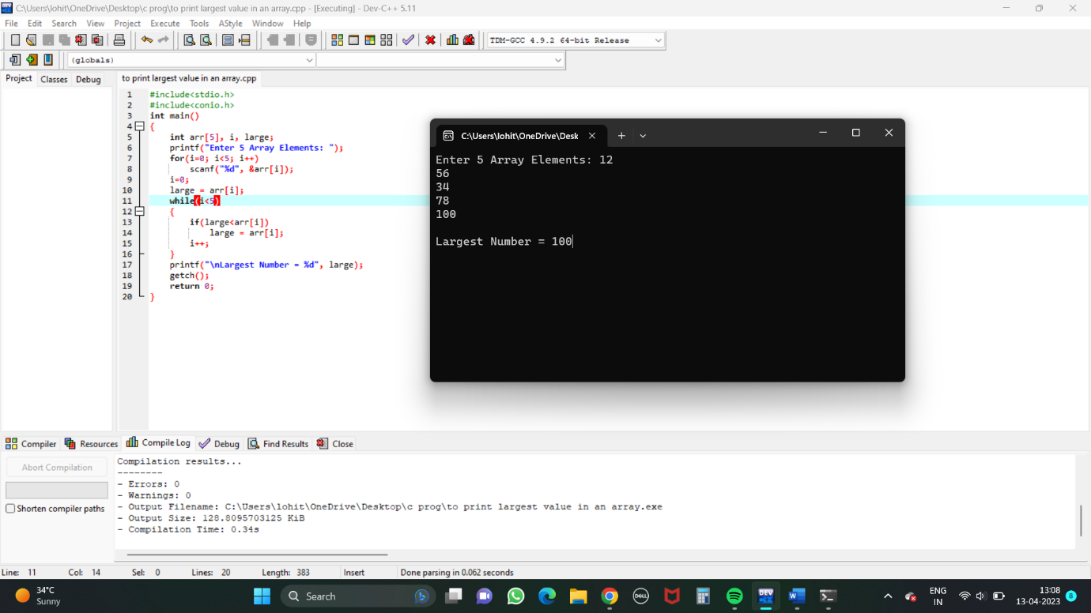

2ND QUESTION (i)

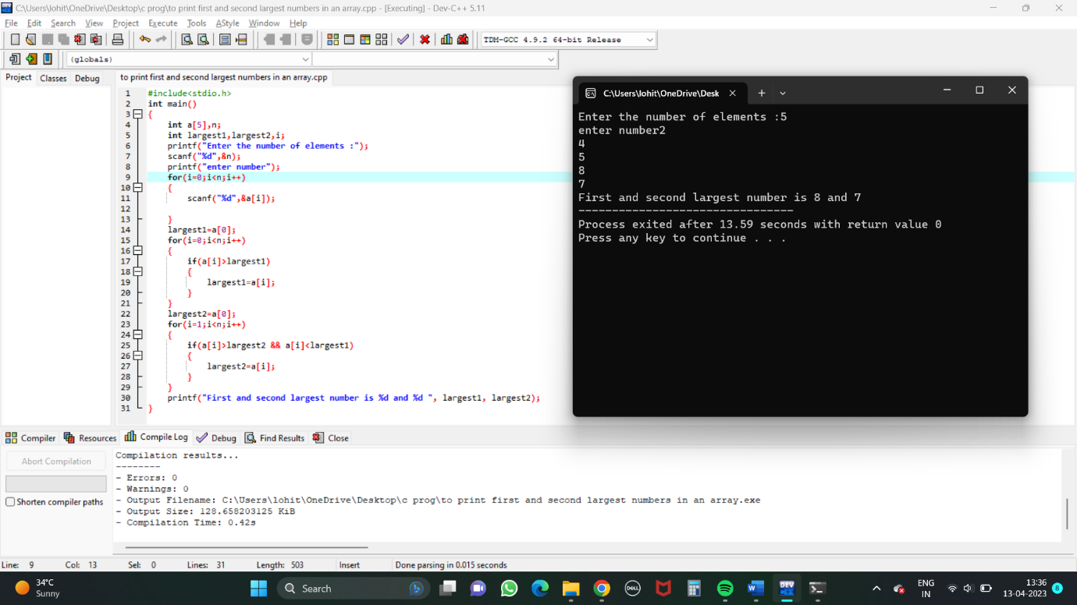

(ii)

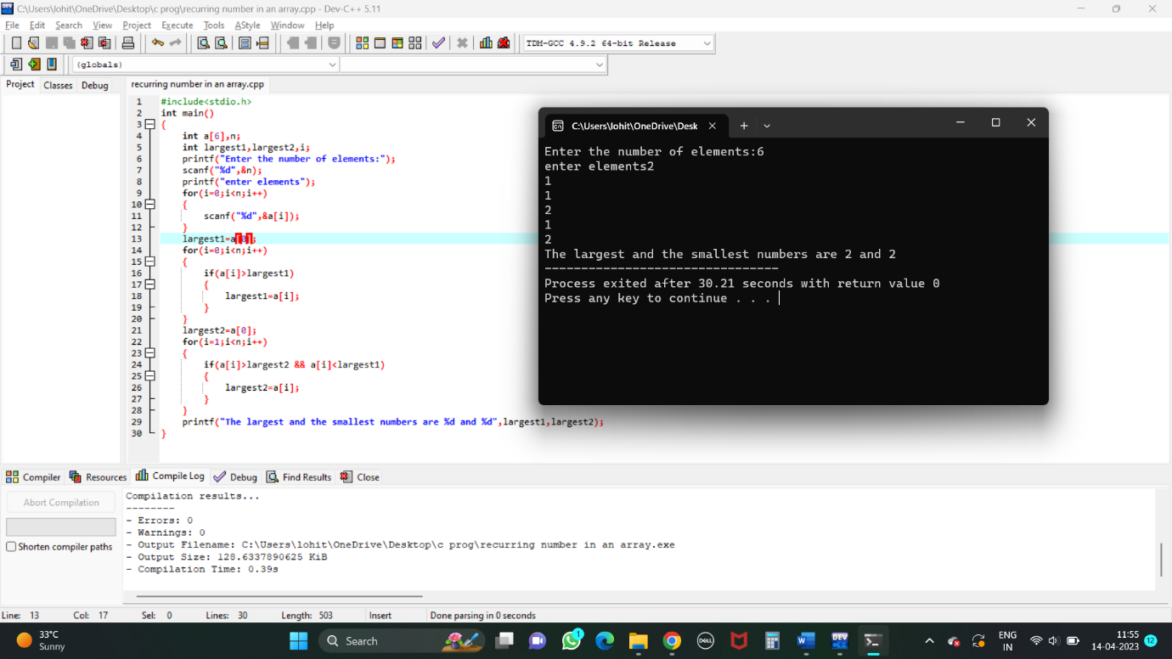

3rd QUESTION

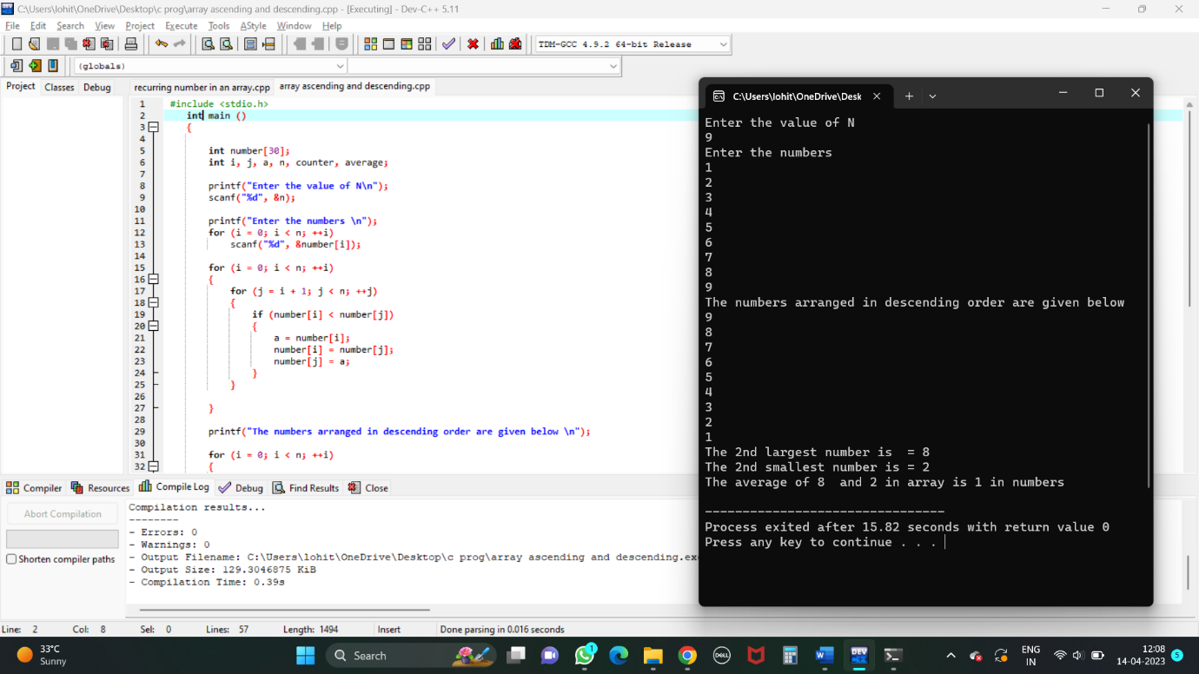

4TH QUESTION

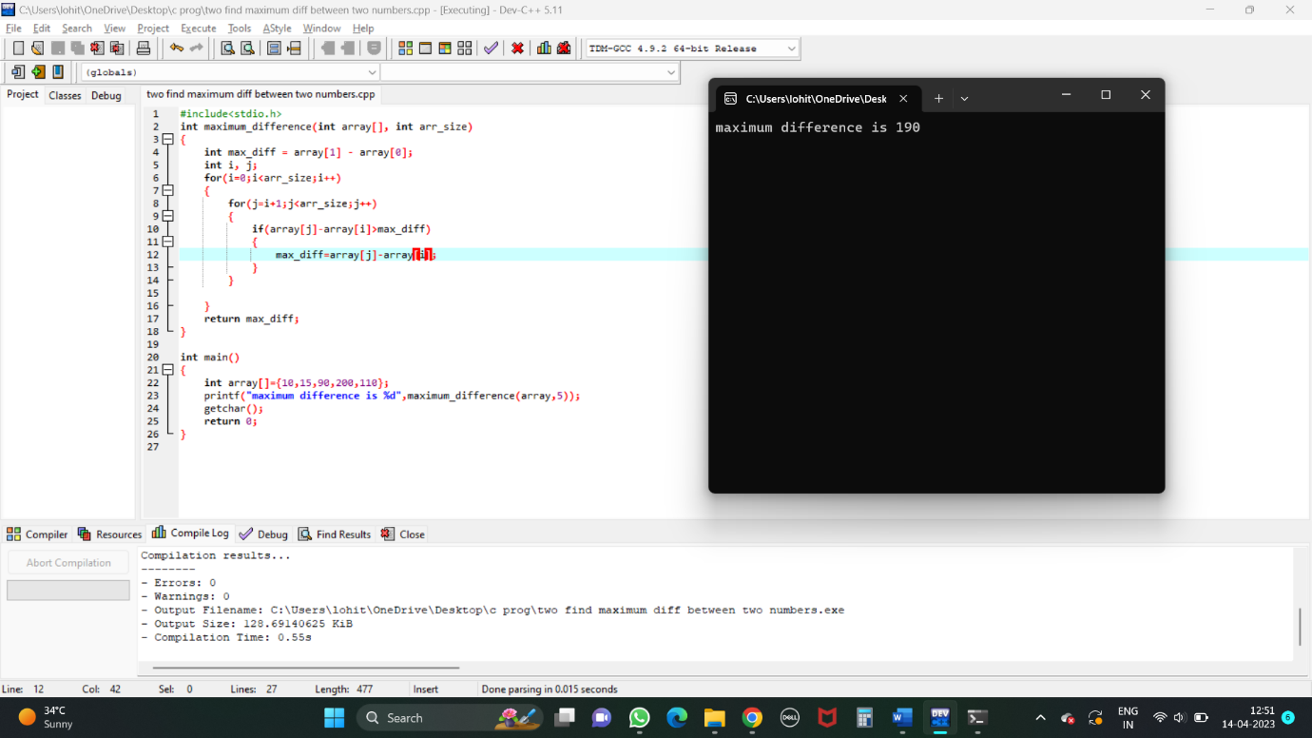

5TH QUESTION

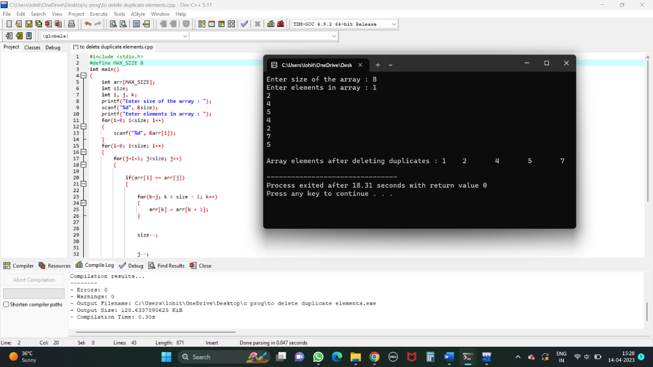

6TH QUESTION

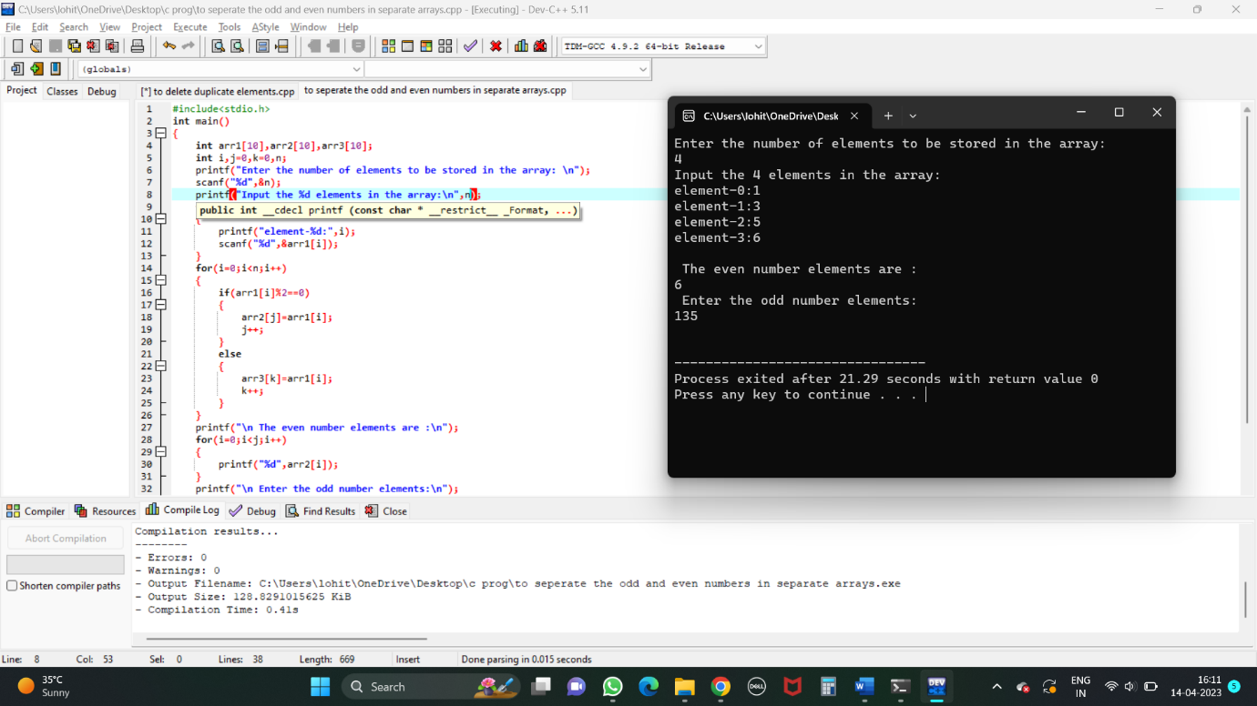

7TH QUESTION

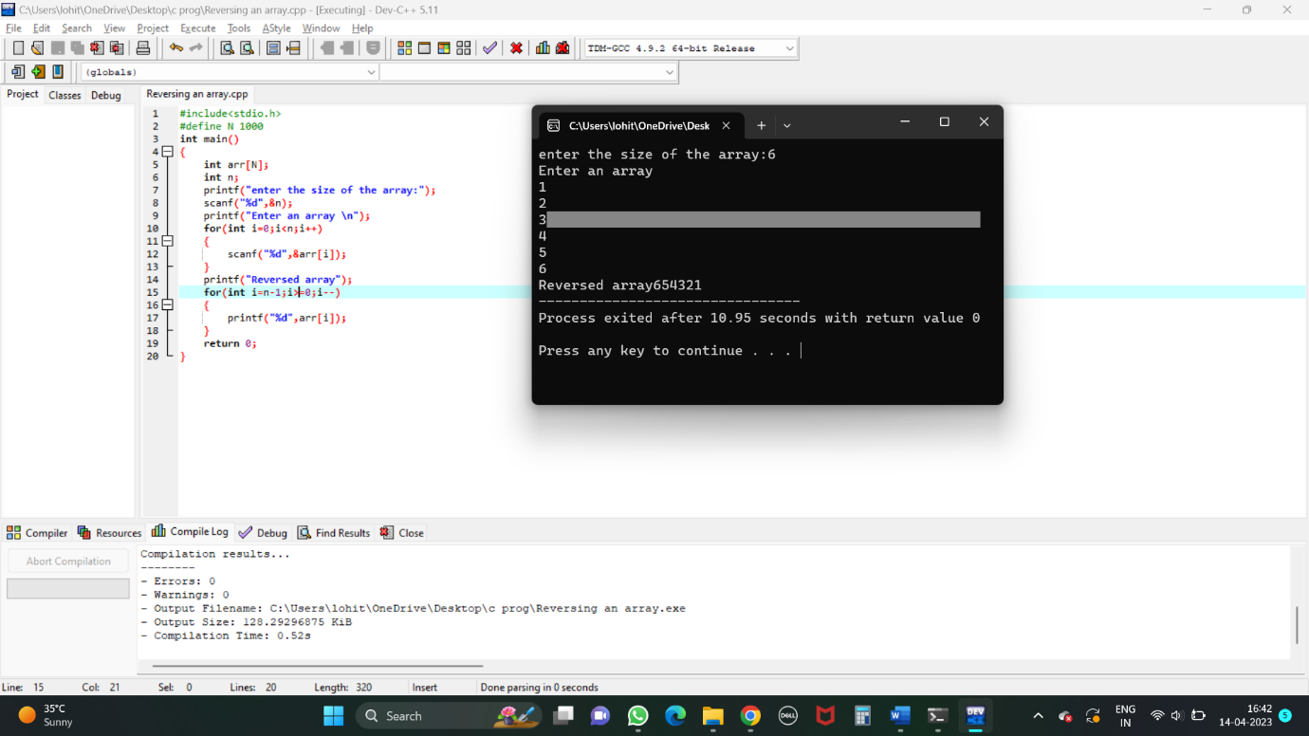

8TH QUESTION

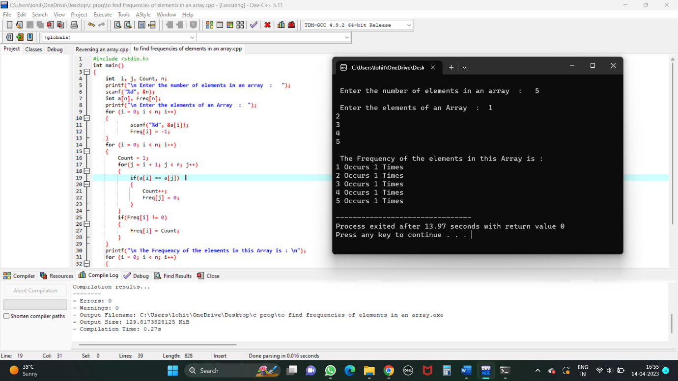

9TH QUESTION

